Step 1: Setup Git Configuration
Description:
Installed Git Bash and configured username and email.
Commands Used:
git --version
git config --global user.name "JONES J"
git config --global user.email "jonesjoel@gmail.com"
git config --global --list
Screenshot(s):
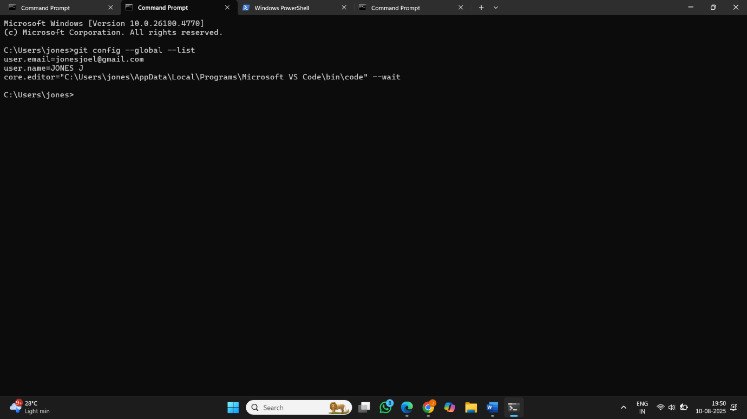

Step 2: Integrate Notepad++ with Git
Description:
Configured Notepad++ as the default Git editor.
Commands Used:
notepad++
git config --global core.editor "notepad++ -multiInst -notabbar -nosession -noPlugin"
git config --global -e

Step 3: Create Local Repository
Description:
Created a folder GitDemo and initialized it as a Git repository.
Commands Used:
mkdir GitDemo
cd GitDemo
git init
Screenshot(s):
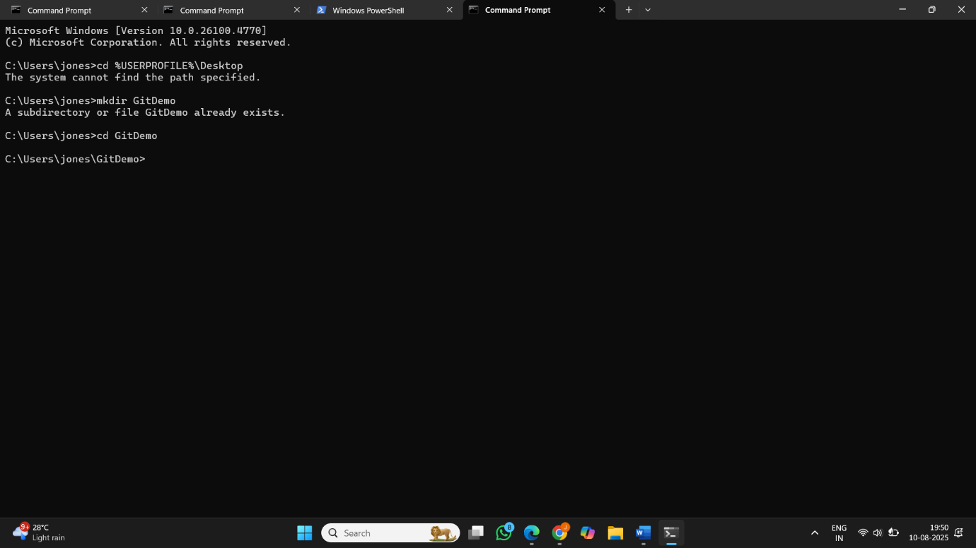

Step 4: Add File to Repository
Description:
Created welcome.txt file and committed it.
Commands Used:
echo "Welcome to Git" > welcome.txt
git add welcome.txt
git commit
Step 5: Push to Remote Repository
Description:
Created GitLab repository and pushed local commits to it.
Commands Used:
git remote add origin https://github.com/jones296/GitDemo.git
git pull origin master
git push origin master

